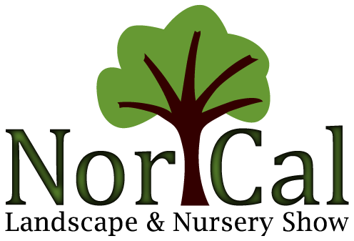
SPONSORSHIP OPPORTUNITIES
Looking for more exposure at the Nor Cal Landscape & Nursery Show? We have several sponsorship opportunities available for you! Sponsorships limited to those exhibiting in show.
General Sponsorship - $350. Signage at show site and on the Nor Cal website. Logo on all Nor Cal e-news throughout the year. Logo linked to your website. Company logo required with payment. Email to margoc@frontiernet.net
Seminar Track Sponsorship – Your logo on the seminar page of the Nor Cal website. Your logo listed with all show sponsor logos on the website. Signage in the Seminar rooms. Logo on all Nor Cal e-news. Limited to one company. Company logo required with payment. Email to margoc@frontiernet.net
Sponsorship Class
Seminar Track Sponsorship – First Come opportunity SOLD FOR 2024
General Sponsorship $350
Signage Deadline is December 31st. Logos must be emailed with completed form.

Name _______________________________________________________________
Company ____________________________________________________________
Address _____________________________________________________________
City __________________________ State _______ Zip code __________________

Credit Card Number: Master Card/VISA ____________________________________
Expiration ___________________ CVV ___________________
Or Check enclosed with form, made payable to Nor Cal Landscape & Nursery Show.
Please fax form to 530-660-5250 or mail to Nor Cal Landscape & Nursery Show. P.O. Box 428, Colusa, CA 95932. For questions contact Margo Cheuvront at margoc@frontiernet.net or 530-458-3190

