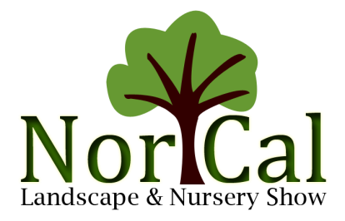
Table of Contents

Welcome Letter 1

Nor Cal Policy Concerning Eligible Exhibitors 3
Exhibitor Quick Facts 4

Move-In and Move-Out Procedures 5

Selling your Booth 7

Show Contacts 8

Transportation information 9

Rules and Regulations 11

Fire Marshal Rules & Regulations 18

Hotel Information 22

Floor Plan 23

Facility Map 24

Name Badge Form 25

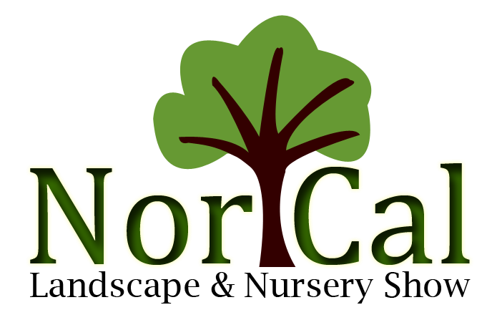
Welcome to the 41st annual Nor Cal Landscape & Nursery Show! We are excited to have you participate in our collaborative event between the Nor Cal Nursery Group and CLCA. We’d also like to extend a special welcome to those of you exhibiting with us for the first time. Nor Cal has a rich history of bringing the green industry together and we’re glad you’re here!

This exhibitor service kit contains the information you will need to successfully exhibit at the show. You can access the service kit, the decorator information, hotel room block and numerous other details online on our website (www.norcaltradeshow.org). Please click on the tab labeled “Information” and then select “Exhibitor Information” which includes the rules and regulations, contact information, floor plan, move-in and out information, name badge form and much more.

Select “Electrical, Furniture & Freight” or use this link to directly access the decorator forms https://sundecorating.boomerecommerce.com/.

Don’t forget to book your hotel room by February 1, 2021 or until the block is filled to be included in the room block. Click the “Hotel Information” tab to make your reservation. The Hyatt Regency San Francisco is our host hotel located just a few minutes from the San Mateo Event Center. Since the show ends on a Thursday evening consider booking an extra night or two and making a weekend out of it. There’s so much to explore in the bay area.

You may register your team either by filling out the enclosed name badge form and sending it back to the office or go online and click “Registration” tab and then select “Exhibitor”.

If your company is planning on having a Show Special at Nor Cal this year let us know! Just send an email to margoc@frontiernet.net and we’ll list your company and booth number on the website and then again in the addendum so that attendees can come by and check it out.

We also want to remind you that Nor Cal contracts with service providers for the show. Our general service contractor or decorator is Sunrise Decorating Co. Inc. We use the Hyatt Regency San Francisco Airport Hotel. Our audio visual Company is Audio Visual Resources. Our electric and plumbing is provided by Edlen Electric Inc. We do not charge for company listings in the directory and you will not be contacted by a third party for any information on the directory. If you are contacted by another company please forward the information to Margo Cheuvront (margoc@frontiernet.net). Do not do business with anyone other than those listed above. If you have a question please contact Margo.

Thank you again for exhibiting with us. We are dedicated to making your experience with Nor Cal a success! If you have any questions please contact Margo Cheuvront, show manager at margoc@frontiernet.net or call 530-458-3190.

Sincerely,

The Nor Cal Landscape & Nursery Show Committee

Nor Cal Policy Concerning Eligible Exhibitors

Approved Exhibitors Only. The “Exhibitor Contract and Booth Space Request”, the formal notice of space assignment, and the full payment of rental charges, constitute a contract between Nor Cal Landscape and Nursery Show (herein called Nor Cal) management and the exhibitor for the right to use the assigned booth space and to exhibit, solicit business or conduct or attempt to conduct any business transaction at or in connection with the Nor Cal tradeshow and comply with these rules and regulations. Nor Cal retains the sole and exclusive right to determine which companies and organizations may exhibit at or participate in the Nor Cal Landscape & Nursery Show.

Prohibited Exhibitors. The show management retains the privilege to restrict exhibitors to products or services of interest and related to the horticultural and landscape trade. In addition, the show management reserves the right to restrict exhibits because of noise, method of operation, materials, or for any reason that is objectionable, and to prohibit or to evict any exhibit which, in the opinion of the show management, may detract from the general character of the Nor Cal Show. This reservation includes persons, things, conduct, printed matter, or anything of a character, which the show management determines objectionable. Exhibitors, including employment, referral and recruiting services, may not solicit and/or recruit employees at any time on the premises of or in connection with the Nor Cal tradeshow. In the event of such restriction or eviction, the show is not liable for any refunds on booth space rental or other exhibitor expenses. This is a partial list of reasons for exclusion from the Nor Cal show; other circumstances may result in refusal to admit an applicant as an exhibitor, in the sole discretion of show management.
Activities Outside of Paid Exhibit Space. Exhibitors must limit their activities to within the confines of their booth space. Exhibitor activities must be conducted in a manner consistent with non-interference of activities legitimately exercised by other exhibitors. The distribution of exhibitor’s products, catalogs, pamphlets, printed material, souvenirs, etc. must remain within the confined area of the booth space and at no time should protrude, at any length, into the exhibit hall aisles. No exhibitor’s promotional activities will be permitted outside the confines of the exhibitor’s booth space. No firm or organization not assigned booth space to the exhibit hall will be permitted to solicit business within the trade show area, unless it has been approved by Show Management. Nor Cal reserves the right to prohibit or restrict other activities that Nor Cal determines in good faith to be disruptive to the tradeshow or convention.
Exhibitor Personnel. A representative company (distributor) may share their space with companies that they represent on a regular basis. The representative company only is responsible for payment of booth spaces to the Nor Cal Show management. Only the person or direct employees of the exhibitor whose name appears at the top of its Exhibitor contract is eligible to work from the booth space or appear on any printed exhibitor list.
Applicability of Policy. This policy shall apply to applicants and exhibitors. In the event that the Nor Cal show has accepted exhibit fees but subsequently in good faith determines that the applicant/Exhibitor is not eligible to be an Exhibitor, the Nor Cal show shall refund all fees paid to the applicant/Exhibitor not later than thirty (30) days after the applicant/Exhibitor is notified of said ineligibility.
Right to Assurances. Nor Cal reserves the right to require, in its sole discretion as a condition of admittance to the show as an exhibitor, written and/or financial assurances from an applicant concerning any circumstance or condition of reasonable concern to Nor Cal.
Violations. Violations of this policy may, in the discretion of Nor Cal, result in the immediate or early ejection of the exhibitor or offending person or entity from the tradeshow or convention, the barring of the violating party from future Nor Cal events, and/or damages resulting from or arising out of said violation, including the costs of security and removal and storage of exhibit booths, materials and utilities.

2021 Nor Cal Landscape & Nursery Exhibitor Quick Facts

Location

Move-In

Name Badge Pick-Up

Exhibitor Packets

Show Hours Exhibitor Access

Move-Out

Show Colors: Green & White

San Mateo County Event Center
1346 Saratoga Drive, San Mateo, Ca. 94403 Telephone: 650-574-3247
Website: www.smeventcenter.com

Tues., February 23 – By Invitation Only Wed., February 24 – Full Move-In Thurs., February 25 - Hand-Carry Only

Wed., February 24 Thurs., February 25

Wed., February 24
Thurs., February 25
Thurs., February 25
Thurs., February 25

Thurs., February 25 - Hand Carry Only, Thurs., February 25- Full Move Out Fri., February 28 – Move-Out 8-10 am Only

1 p.m. – 5 p.m. 8 a.m. – 7 p.m.
7 a.m. – 7:30 a.m.

10 a.m. – 7 p.m. 7 a.m. – 5 p.m.

8 a.m. – 7 p.m. 7 a.m. – 8 a.m.

8 a.m. – 4 p.m. 7 a.m. – 8 a.m.

4:30-5:30 p.m.
5:30 – 9:00 p.m.

Booth Equipment The exhibitor booth will be set with 8’ high green and white background drape, 3’ high green side divider drapes and 7” x 44” booth identification Sign to include exhibiting company name, city, state and booth number. One identification sign per exhibitor unless more are requested.

Decorator Services Use this link: https://sundecorating.boomerecommerce.com/
Sunrise Decorating Company, Inc. P.O. Box 4195, Sunland, Ca. 91041
818-272-0555 – Joseph Sheppard jsheppard@sundecorating.com

--
2021 Nor Cal Landscape & Nursery Move-In and Move-Out Procedures

Dates: Tuesday, February 23rd Decorator Move-In 8 a.m. to 5 p.m.
Tuesday, February 23rd Exhibitor Move-In by invitation 1 p.m. to 5 p.m. Forklift Available
Wednesday, February 24 Full Exhibitor Move-In 8 a.m. to 7 p.m. Forklift Available
Thursday, February 25th Hand Carry Move-In ONLY 7 a.m. to 7:30 a.m.
Thursday, February 25th Show Day 8 a.m. to 4 p.m.
Thursday, February 25th Full Move-out 5 p.m. to 9 p.m.
Friday, February 26th Final Move-out 8 a.m. to 10 a.m. Forklift Available

Move-In
Tuesday, February 23rd from 1 p.m. to 5 p.m. is open to exhibitors with concrete, equipment, rocks, boulders etc. that require extra time. Each exhibiting company must make arrangements through the show manager (margoc@frontiernet.net or 530-458-3190) to participate in this by invitation move-in.

Full exhibitor move-in will begin at 8 a.m. on Wednesday, February 24th Forklifts are available from 8 a.m. until 7 p.m. You can also hand carry your materials into the hall. The hall closes for move-in at 7 p.m. All exhibit space must be ready by 7 p.m. On Thursday, February 25th hand carried items can be brought in to the hall from 7 a.m. until 7:30 a.m. Show Hours: 8 a.m. to 4 p.m. on February 25th.

There will be 3000 lb. forklifts available on a first come, first served basis. Forklift operators will be instructed to place your booth equipment or plant material in your booth space, but will not stay to arrange plant material or equipment. Please send enough assistance for your needs. Temporary labor can be arranged through the decorator. Forklifts needed for more than moving 3000 lbs. are not available. If you require one to unload your material you must make arrangements with the decorator.

If you require a reset on your booth materials with a forklift there will be an additional charge. Please check at the decorator’s desk for details.

Cranes
Cranes are not available. If you require one to unload your material you must bring your own crane that is specifically affixed to your vehicle. Please contact show management (margoc@frontiernet.net or 530-458-3190) and Sunrise Decorating (Joseph Sheppard, 818-272-0555 or jsheppard@sundecorating.com) to arrange moving in before Sunrise begins building the booths.

All booth spaces must be completed by 7:30 a.m. on Thursday, February 25th. The Nor Cal committee will conduct a walk through inspection and incomplete booths revert back to show management. No refund will be given for unoccupied spaces.

Parking Location
The San Mateo Event Center is located at 1346 Saratoga Drive, San Mateo, Ca. 94403.
Driving Directions to the San Mateo Event Center From Highway 101 North
Take 92 West. Exit on the Delaware Street Exit. Turn right on Delaware and follow the signs to the event center, 1346 Saratoga Drive, San Mateo, Ca. 94403. At the corner of Delaware and Saratoga turn left. The event center will be on your right. Turn right at Event Center Drive which is the opening to the event center property - 5 -

2021 Nor Cal Landscape & Nursery Move-In and Move-Out Procedures

From Highway 280
Take 92 East. Exit on the Delaware Street Exit. Turn right on Delaware and follow the signs to the event center, 1346 Saratoga Drive, San Mateo, Ca. 94403. At the corner of Delaware and Saratoga turn left. The event center will be on your right. Turn right at Event Center Drive which is the opening to the event center property.

From 101 South
Take exit 414A for Hillsdale Blvd., Turn Left at E. Hillsdale Blvd., Right on Saratoga Drive. The event center is on your left. Turn left at Event Center Drive which is the opening to the event center property.

On Property Directions
Once you have arrived on the San Mateo Event Center property proceed toward the line of vehicles on the south side of the parking lot if you are delivering materials to the show. If your vehicle requires the use of a forklift you will be directed to the East side of Expo Hall. If your vehicle can be hand unloaded it will be directed to the doors nearest your booth spaces. Committee and volunteers will direct you to an unloading spot.

ATTENTION: Nor Cal is a Package show. This means that unloading/loading of your exhibit materials, the use of forklifts, the storage and return of empty crates and cartons is already included in your booth space rental. Please do NOT tip the teamsters. If you have trouble with any union personnel please report a description or name to the show manager or a committee member.

If you are an exhibitor setting up your booth spaces please park in any available spaces outside the fenced area near Expo Hall. Expo Hall is the large building at the south end of the facility. Proceed through the pedestrian gate (between Gates 6 & 7) into Expo Hall. Volunteers and committee can direct you to your booth spaces. Registration is located near the East entrance. You can pick up or order name badges there as well as pickup your Exhibitor packet.

Move-Out
Before exhibits can start to be removed on Thursday evening, all aisle carpeting will be removed starting at 4:30 p.m. (after close of the show). It will take approximately 45 minutes to remove the carpet. Roll up doors will not be opened and empty cartons/cases returned until the carpet is removed. Empties will be returned within 2 hours of the carpet removal.

Take all valuables out of the booth first. Do not leave briefcases, money and computers in the booth during tear down. This is your first responsibility. If you are leaving materials in your booth overnight be sure they are secured. There will be no overnight security. Only hand carried items can be taken out of the hall during the first hour.

If you are having freight shipped through Sunrise Decorating have all of the boxes clearly marked with proper labeling. See the Sunrise service desk for information and tags. They are located in the southeast section of the hall toward the East parking lot, near the rollup door.

- 6 -

2021 Nor Cal Landscape & Nursery Move-In and Move-Out Procedures

If you are selling your booth materials to someone: Do the Following:
✓Leave a sign in the booth with the name of the company, cell phone number and contact name when you leave the show. (See the back side of Move-Out Memo available on show day.)

✓Tell the customer they can pick materials up between 6 p.m and 9 p.m. on Thursday, February 25th and 8 a.m. and 10 a.m. on Friday, February 26th. ALL MATERIALS MUST BE OUT OF THE HALL BY 10 A.M. on Friday.

✓The hall closes at 9 p.m. on Thursday, February 25th. The hall reopens at 8 a.m. until 10 a.m. on Friday. Anything left after 10 a.m. will be left outside the hall in an unsecured area. $250 fine per hour will be incurred by any company whose product is still in the hall at 10 a.m. Any questions or concerns – come to the show office.

Parking Passes
Parking on Wednesday, February 24th is FREE. You may purchase a parking pass for show day online. The link will be emailed out the week before the show. This pass must be placed inside the windshield on the driver side of the car. There are NO in and out privileges. You can also purchase a pass on February 25th at the tollbooth as you enter the facility grounds. The price on show day is $15 per car. You can purchase your passes with cash or credit card.

Overnight Truck parking will be available. Please check with Show Management for the specific area once you are onsite.

- 7 -

2021 Nor Cal Landscape & Nursery Show Contacts

Show Manager
Nor Cal Landscape and Nursery Show Contact: Margo Cheuvront
Mailing Address: PO Box 428, Colusa, Ca. 95932 Physical Address: 89 Oak Tree Lane, Colusa, Ca. 95932
Telephone: 530-458-3190 or 916-769-1945 cell Fax: 530-660-5250
Email: margoc@frontiernet.net

General Services (Decorator, Drayage)
Sunrise Decorating Company, Inc.
Contact: Joseph Sheppard
Mailing Address: PO Box 4195, Sunland, Ca. 91041 Telephone: 818-272-0555 cell phone
Fax: 818-450-0326
Email: jsheppard@sundecorating.com

Audio Visual Services AV Resources
Contact: Peter Morucci
Address: 150 Anza Blvd., Burlingame, Ca. 94010 Telephone: 650-348-0400 Fax: 650-342-8109 Email: peter@avresources.com
Website: www.avresources.com

Facility
San Mateo County Event Center
Administration Office: 2495 S. Delaware St., San Mateo, Ca. 94403
Event Address: 1346 Saratoga Drive, San Mateo, Ca. 94403
Telephone: 650-574-3247
Website: www.smeventcenter.com

Bureau of Fire Protection and Life Safety 1040 E. Hillside Blvd., Foster City, Ca. 94404
Telephone: 650-533-7940 Fax: 650-522-7941
Edlen Electric
Contact: Audra Williams
Telephone: 650-225-0900
Fax: 650-225-0950
awilliams@edlen.com

Catering
Creative Touch Catering & Food
Address: 2495 S. Delaware Street, San Mateo, Ca. 94403
Telephone: 650-574-3247 ex.340
Fax: 650-574-3985
Website: www.smeventcenter.com

Security
Contact the San Mateo Event Center

Internet and Wireless Services
Contact: Events Department, San Mateo Event Center
Address: 2495 S. Delaware Street, San Mateo, Ca 94403
Telephone: 650-574-3247 Fax: 650-574-3985 Email: eventservices@smeventcenter.com Website: www.smeventercenter.com

Hotel
Hyatt Regency San Francisco
1333 Bayshore Hwy.
Burlingame, CA 94010
Reservations: 888-421-1442
$255 rate plus applicable taxes Self- Parking & WIFI - FREE
Deadline for Reservations: February 1, 2021 or until room block has been filled.

San Mateo County Agriculture Department
728 Heller Street, Redwood City, Ca. 94063
Telephone: 650-363-4700 Fax: 650-367-0130
Email: smateoag@smcgov.org

2021 Nor Cal Transportation Information

There are three major airports within 90 minutes of the facility: San Francisco International, Oakland International, San Jose International.

San Francisco International to the San Mateo Event Center (Approximately 9 miles/15 minute drive without traffic)
Head east on Airport Access Road toward T-1 Turnaround. Turn slightly left toward US – 101/I-380/I-280. Turn slightly left onto Airport Access Road.
Merge onto US – 101 S/Bayshore Fwy S toward San Jose. Approximately 7 miles. Merge right onto CA-92/J. Arthur Younger Fwy W via Exit 414B toward Half Moon Bay.
Remain in the right hand lane. Take Exit 12C toward Delaware St./Event Center. Merge onto Concar Dr.
Take the first right onto S. Delaware St. (Shell Gas station on the corner).
Turn left onto Saratoga Drive. (Saratoga Drive. is just past Pacific Blvd., if you reach E. 25th Ave. you’ve gone 0.1 miles too far. 1346 Saratoga Dr. is on the right at a signal light. Turn right on Event Center Drive to property.

Oakland International to the San Mateo Event Center (Approximately 25 miles/30 minute drive without traffic)
Start out going west on Airport Dr. toward Alan Shepard Way. Keep left at fork to continue on Airport Dr. then at the next fork keep right to continue on Airport Dr. Stay straight to go onto 98th Ave. Merge onto I-880 S/Nimitz Fwy S toward San Jose.
Take the Jackson St. exit, Exit 27, toward CA – 92 W/San Mateo/Half Moon Bay/CA – 92 E/Downtown. Keep right to take CA – 92 W ramp toward San Mateo/Half Moon Bay/San Mateo Bridge. The San Mateo Bridge is a toll bridge. The cost is: $5. After crossing the San Mateo Bridge, get past the 101 exit and then get in the right lane. Take Exit 12C toward Delaware St./Event Center. Merge onto Concar Dr. Take the first right onto S. Delaware St. (Shell Gas station on the corner). Turn left onto Saratoga Drive. (Saratoga Dr. is just past Pacific Blvd., if you reach E. 25th Ave. you’ve gone 0.1 miles too far. 1346 Saratoga Dr. is on the right at a signal light. Turn right on Event Center Drive to property.

San Jose International Airport to the San Mateo Event Center (Approximately 27 miles/35 minute drive without traffic)
Depart Airport Blvd. toward Evert Road. Bear left onto Evert. Take ramp left for CA – 87N/Guadalupe Parkway. At exit 9B, take ramp left for US – 101 N toward San Francisco. Approximately 23.7 miles at exit 414A take ramp right and follow signs for Hillsdale Blvd. Turn left onto Hillsdale Blvd followed by a right onto Saratoga Dr. Follow to Event Center Drive. Turn left onto property.

Train Transportation Information
Check the website for the current information: www.caltrain.com

- 9 -

2021 Nor Cal Transportation Information

Bay Area Rapid Transit (BART) www.bart.gov

Bus Transportation Information www.samtrans.com

BART/CalTrain Transportation to San Mateo Event Center
1. Exit the Millbrae Bart Station across the parking lot to the Millbrae CalTrain Station. 2. At Millbrae station connect to the Southbound CalTrain going toward San Jose.
3. Exit at the Hillsdale State to El Camino Real Blvd. 4. At Hillsdale you can either walk, take a bus, or taxi.

If you choose to walk: Take El Camino Real and head north. Turn right onto E. 25th Avenue and the San Mateo Event Center will be at the end of the street. It is approximately ½ mile walk.

If you choose to take the bus: Take El Camino Real Blvd heading north, and stay on the bus for a few stops. Exit at El Camino Real and 25th Avenue. Turn right on E. 25th Avenue. The San Mateo Event Center is two blocks ahead at 2495 S. Delaware St.

Foot Traffic Location: 1346 Saratoga Drive, San Mateo, Ca. 94403. If you are arriving on foot or by bus please enter at 2495 S. Delaware Street, San Mateo, Ca. Enter through the turnstiles. Expo Hall will be to your far right. Walk down the road on the left of Expo Hall. Turn right at the end and enter Expo Hall.

Driving Directions to the San Mateo Event Center From Highway 101 North
Take 92 West. Exit on the Delaware Street Exit. Turn right on Delaware and follow the signs to the event center, 1346 Saratoga Drive, San Mateo, Ca. 94403. At the corner of Delaware and Saratoga turn left. The event center will be on your right. Turn right at Event Center Drive which opens onto the event center property.

From Highway 280
Take 92 East. Exit on the Delaware Street Exit. Turn right on Delaware and follow signs to EVENT CENTER. – 1346 Saratoga St., San Mateo, Ca. 94403. At the corner of Delaware and Saratoga turn left. The event center will be on your right. Turn right at Event Center Drive which opens onto the event center property.

From 101 South
Take exit 414A for Hillsdale Blvd., Turn Left at E. Hillsdale Blvd., Right on Saratoga Drive The event center is on your left. Turn left at Event Center Drive onto the property.

- 10 -

2021 Nor Cal Landscape & Nursery Rules and Regulations

1. Contract for Space
The “Exhibitor Contract and Booth Space Request”, the formal notice of space assignment, and the full payment of rental charges, constitute a contract between Nor Cal Landscape and Nursery Show (herein called Nor Cal) management and the exhibitor for the right to use the assigned booth space and to comply with these rules and regulations.

Booth payment schedule: You will be billed in March. Each 10x10 booth is $1050 member/$1200 Non-member. 1st half of payment due August 1st and balance due September 1st. Exhibit space cancellation will result in loss of money paid. 5% discount for booking 5 spaces; 10% discount for booking 6-8 spaces; and 30% discount booking 9+ spaces.

In the event the exposition is not held for any reason beyond the control of the show management, the rental and lease space to the exhibitor will be canceled upon return of the rental paid by the exhibitor. Return of the rental money will terminate any liability upon the Nor Cal Show. Show management reserves the right to cancel any contract with any exhibitor at any time prior to the show on not less than 2 hours notice.

Floor Weight Limit
The San Mateo Event Center (SMEC) has a weight limit on the trade show floor. No more than 400 lb. sq. ft. can be accommodated.

2. Space Assignment
Space assignment is made on a priority system based on the number of years an exhibitor has been in the show. A priority number entitles the exhibitor to select one or more booths as need for their display.

“Sharing” of a priority number by multiple firms is prohibited”. After the firms on the priority list have signed up for booth space, space assignment will be on a first come basis. In the event that firms on the priority list are unable to select a booth because no space is available, they will be given first choice of any space which becomes available.

Show management will make every effort to place the exhibitor in the area of his/her choice, and, once a space is paid for; confirm the space to that exhibitor. However, the show management reserves the right to place, move or relocate any exhibitor for the total benefit and operation of the show.

3. Island Booths
a) Walled or closed structures are not permitted in these areas except as noted in 3-b.
b) Height limitations: a limit of 15’ is imposed on all structures and or equipment, but must not infringe upon the 5’ outside perimeter of space. A limit of 8’ applies to the 5’ outside perimeter space. Freestanding signs will be limited to a height of 12’.
c) Any questions regarding the above booth areas will be referred to the Nor Cal Show Management.

4. Hanging Signs
Exhibitors in Island Booths will be permitted to have hanging signs above their booth(s). The following criteria MUST be followed or the Nor Cal committee will have the sign removed.

- 11 -

2021 Nor Cal Landscape & Nursery Rules and Regulations

Hanging signs must be visible by all sides or circular.
Permitted over the island booth space only.
Signs must be centered in the booth. Maximum height 18’ and maximum
width must be within 5’ perimeter of the booth.
Example: 20x20 booth = 400 sq. ft. Each side of the sign may not exceed 40 sq. ft. Cost of hanging the banner can be arranged with Sunrise Decorating Co, Inc., the official show decorator.

5. Cancellation
If an exhibitor cancels booth space reservations at any time, there will be no refund of any deposit or booth rental money. If an exhibitor rents a booth, pays in full, but does not attend the show, the act of renting and implying that the exhibitor will attend is the same as if the exhibitor did attend the show. Therefore, no refund of booth rental monies will be made because the exhibitor was unable to exhibit at the show.

Exhibitors who sign up for space locations that have been sold as assigned blocks of two, three or four units may not then decide to cancel one, two or three of those spaces and keep a space that is part of that unit. If an exhibitor signs up for block units of booths, he must either rent or cancel all of them.

6. Sub-Leasing of Space No Exhibitor may assign, sublet or
apportion the whole or any part of the booth space assigned to him(exception see 7), nor permit any other party to exhibit therein, not to distribute any promotion or advertising materials in the occupied space
of the exhibitor except as may be permitted by request through the show management.

7. Representatives
A representative company (distributor) may share their space with companies that they represent on a daily basis. The representative company only is responsible for payment of booth spaces to the Nor Cal Show management. Only one bill will be submitted to the representative company for payment. Any company sharing space with their representative will continue to hold their priority number in the show should they separate from the representative. Companies sharing space with a representative will not have their own listing in the directory. The representative may have the companies listed under their name in the product description section.

8. Exhibitor Solicitations Exhibitors must limit their activities to within the confines of their booth space. Exhibitor activities must be conducted in a
manner consistent with non-interference of activities legitimately exercised by other exhibitors. The distribution of exhibitor’s products, catalogs, pamphlets, printed material, souvenirs, etc. must remain within the confined area of the booth space and at no time should protrude, at any length, into the exhibit hall aisles. No exhibitor’s promotional activities will be permitted outside the confines of the exhibitor’s booth space. No firm or organization not assigned booth space to the exhibit hall will be permitted to solicit business within the trade show area, unless it has been approved by Show Management.
9. Character of Exhibits

- 12 -

2021 Nor Cal Landscape & Nursery Rules and Regulations

The show management retains the privilege to restrict exhibitors to products or services of interest and related to the horticultural and landscape trade. (See pg. 3) In addition, the show management reserves the right to restrict exhibits because of noise, method of operation, materials, or for any reason that is objectionable, and to prohibit or to evict any exhibit which, in the opinion of the show management, may detract from the general character of the Nor Cal Show. This reservation includes persons, things, conduct, printed matter, or anything of a character, which the show management determines objectionable. In the event of such restriction or eviction, the show is not liable for any refunds on booth space rental or other exhibitor expenses.

Exhibitors may furnish their own tables and chairs if desired. Additional equipment, booth furnishings and services may be ordered on forms which are available online.

No type of product including plant material may be outside of the allotted booth space. Overhanging plant limbs or products are not allowed. Plant material can be over 8’ in height as long as it does not hang over into adjoining booth spaces or block the view of adjoining booths.

10. Care of Exhibit Space Cleaning of the aisles will be provided by the Nor Cal Show. Exhibitors are asked to cooperate by not throwing refuse on the floor, or any other material, which will endanger public safety or inconvenience other exhibitors during show hours.

Cleaning of exhibitor booth spaces must be arranged through the decorator firm and paid for by the exhibiting firm. This is the
sole responsibility of the exhibitor. The Nor Cal Show will not be held responsible financially or otherwise for this service.

Exhibits must be put in proper shape and in order before opening hour of show day. Show management, at the expense of the exhibitor, may straighten booths not in order before opening hour. Exhibitors shall not injure, mar, mark, paint, or in any manner deface exhibition hall premises; nor drive any nails, hooks, tacks, pins or screws or similar materials, or append cellophane tape, masking tape etc. on any part of the exposition building. An exhibitor shall be liable for any and all damages which he/she may cause to the building or otherwise in connection with his/her exhibit.

11. Booth Decoration
The Nor Cal Show will supply standard booth equipment consisting of rear back wall curtains on a frame not to exceed 8’ in height, two side dividers of curtains on frames not to exceed 3’ and one identification sign per exhibiting company. All other booth equipment and decorations will be supplied either by the individual exhibitor or may be rented from the show decorator.

12. Materials Display Configuration
Exhibit displays may not exceed more than 8’ in back wall height from the exposition floor and must be confined to the rear one-third (3’) of each booth, unless permission is received from show management to do otherwise.
Those exhibitors having the 10x20 or 20x20 booths on the end of each row are subject to a different back wall, 8’ in height and 10’ in width, which is centered on the 20’ back

- 13 -

2021 Nor Cal Landscape & Nursery Rules and Regulations

wall leaving a 5’ wide by 3’ high back wall on each side. Exhibits in a full-height back wall are not allowed in end cap booths. Material display arrangement in all booths must allow a view line to adjacent booths.

13. Special Equipment Restrictions
The operation of oil, diesel, or gasoline engines is prohibited and all such engines must be free of all such fuels while on display in the exhibit area. Please refer to the Fire Marshal regulations posted at the end of the Rules & Regulations for complete details. Fuel caps must be locked or taped. The Fire Marshal will be onsite on show day for inspections and failure to comply with regulations may subject you to a penalty and all costs incurred.

Audio-visual equipment must meet fire prevention requirements and must be in harmony with any agreements entered into by the show management, the management of the exhibit hall, and applicable labor unions. The use of loud speakers and public address equipment is prohibited. Exhibits, which include the operation of musical instruments, radios, or any noise-making equipment and flashing light must be conducted or arranged so the noise resulting from the demonstrations will not annoy or disturb adjacent exhibitors. Show management must approve all plans for installation and operation of special equipment before operation is initiated. No balloons can be placed higher than 8’ from the floor. The use of robots or specially dressed mascots is allowed within the confines of the booth. The movement of these mascots from one booth to another or in the aisles during the show hours is forbidden.

14. Spotting Fees
When a mobile unit is required to be placed in the exhibitor’s booth, a spotter is required to walk with the unit from the dock to the booth. A spotting fee will be charged for this service. This service will provide one person who will walk in front of the motorized vehicle to insure that a clear path is made for the driver. The spotter will move any freight, deco equipment, back wall or pedestrians, out of the path of the vehicle to insure safe passageway to the destination. The exhibitor is responsible for all fees incurred. Forms are available through the decorator.

15. Removal or Sale of Exhibit Materials
“Over the counter “sales at the show are strictly prohibited. The sale of individual items where the purchaser would take possession of the item prior to the close of the show is not permitted.
This policy does not in any way restrict the normal trade show sales activities of taking orders of materials for delivery after the Nor Cal Show is closed.

Distribution of brochures, circulars or other printed material, yard sticks, seedlings, shopping bags etc. will be allowed if conducted in exhibitors’ booth, provided it does not interfere with the security or atmosphere of the show.

Show Management seeks to be in compliance with the federal tax law of 1976, whereby retail sales are forbidden for non-profit associations. The sale or give-away of merchandise materials used as display items in the exhibit booth is permitted at the show; however, once the

2021 Nor Cal Landscape & Nursery Rules and Regulations

exhibit booth has been stocked with exhibit materials, no materials whatsoever will be allowed to leave the show floor at any time prior to closing time of the show.

This policy is to assist the exhibitor in preventing theft of exhibit material and to encourage exhibitors to keep exhibit materials in their booths until the end of the show. Selling and depleting booth merchandise during the show detracts from the overall effectiveness of the show and does not allow last minute buyers the opportunity to see complete exhibits. If any material is sold or given away, the list needs to be reported to show management in writing prior to the removal of the material.

16. Food & Drink
The San Mateo Event Center has exclusive rights for the sale of all food and drink within the exhibit hall and on the premises; thus, neither may be sold on the San Mateo Event Center property. If an exhibitor wishes to give food or drink as promotion for his/her booth, he/she should contact the San Mateo Event Center at 650-574-3247 ex. 334.

17. Insurance and Liability
Since neither the Nor Cal Show nor the San Mateo Event Center covers individual displays with liability insurance, exhibitors are required to carry certificate of liability insurance to cover exhibit materials against damage, loss and public safety while participating in this show.

Further, the exhibitor, upon rental of booth space, releases and agrees to indemnify and hold harmless the Nor Cal Trade Show, the show committee and show manager, PCA and CLCA against any and all claims
for the following: loss, damage, costs, expense (including attorney fees), claims, suits, and any judgments whatsoever in connection with injury to, or death of, any persons; loss or damage to any property, arising at or in any way connected with the performance of the exhibitor, their personnel or equipment while at the show or traveling to or from the show, or a result of the act of any attendee. All property of the exhibitor is understood to remain in their custody and control in transit to and from the show, or within the confines of the San Mateo Event Center, subject to the rules and regulations of the show.

Neither the show, nor the service contractors, nor the management of the San Mateo Event Center, not the City of San Mateo, nor the Nor Cal Nursery Group nor the show manager , nor the Plant California Alliance nor the California Landscape Contractors Association, nor any officer and/or staff members of the above entities will be responsible for any injury, loss or damage that may occur to the exhibitor, his/her employees, or any others designated by him/her, for thefts, strikes, damage by fire, water, storm, vandalism, acts of God, or from any cause whatsoever, prior, during or subsequent to, the period of the show. In addition, the show or show management will not be liable for any expense, cost of liability that the exhibitor may try to insure against the show.

18. Fire Laws
Federal, State and City fire codes must be strictly enforced. The San Mateo County Fire code is listed on the Nor Cal website as well as included at the conclusion of these

- 15 -

2021 Nor Cal Landscape & Nursery Rules and Regulations

rules and regulations. Every exhibiting firm is expected to comply with these rules!
If inspection indicates that any exhibitor has neglected to comply with these regulations, or otherwise incurs a fire hazard, the right is reserved to cancel all or such part of the exhibiting firms display as may be irregular.

19. Labor
Exhibitors are required to comply with the union labor regulations as determined by the show management and local unions. Any exhibitor may install and/or dismantle their display providing the total time for the installation does not take more than 30 minutes for one person to complete. (This does not mean 2 people for 15 minutes). If the installation or dismantling requires more than 30 minutes, properly qualified union personnel must do the work. An exhibitor may work with a union installer on a ‘one to one’ basis provided they are a permanent employee of the exhibiting company. Representatives or stewards of the union will be on the floor during move in and move out. They will be checking constantly to see that all exhibitors are complying with the rules.
SHOW MANAGEMENT HAS NO AUTHORITY WHEN THE UNION REPRESENTATIVES ENFORCE THEIR REGULATIONS.

20. Security
The show management will provide basic security service at the San Mateo Event Center from 6 p.m. Wednesday night to 7 a.m. Thursday morning. As further protection, the show management encourages each exhibitor to have at least one employee in the booth during the hours of move in and PARTICULARLY during the hours of move out, so that each exhibitor will assist in the security of their individual materials. Please remove all
important documents, laptops, etc. first thing when tear down begins. The show management also encourages manning of the exhibit booth at all times during regular show hours by qualified regular employees of the exhibitor. However, in all cases, the ultimate responsibility of security lies with the exhibitor at all times, and the show management will not be held liable for the loss or theft of any or all items from an exhibit booth.

21. Plant Inspection
Those exhibitors who are growers or suppliers of green goods that are not from California or live within restricted counties, upon entrance into the state of California, must notify the Department of Agriculture that their plant materials must be inspected. The San Mateo County Agriculture Commissioners Office is 728 Heller Street, PO Box 999, Redwood City, Ca. 94064. 650-363-4700 or smateoag@smcgov.org

The Ag Commissioner will be onsite on show day doing inspections.

22. Licenses and Permits
The exhibitor shall procure at their expense and own cost, any necessary licenses and official permits for the purpose of displaying and exhibiting merchandise at the San Mateo Event Center. All local laws, rules and regulations must be adhered to.

23. All Dry Goods Products
All dry goods products must be displayed in dummy bags, boxes, plastic containers. No “live” chemicals or organics may be displayed in the hall. The show is fined $250 per instance and will pass the fine on to the exhibitor. If you have a question contact Margo (margoc@frontiernet.net).

2021 Nor Cal Landscape Nursery Rules and Regulations

24. Change of Dates
If the show management considers it inadvisable to hold the exposition at the time and/or the locations herein provided, the show management has the right to change the dates, and/or location within the same city or county. The exhibitor will be given written notice of such changes to the address shown on the exhibitor’s contract.

25. Hospitality Suites
The Nor Cal Show committee deems it in the best interest of the show to prohibit hospitality suites during the show hours.

26. Non-Compliance to Rules & Regulations
Each exhibitor, for themselves and their employees, agrees to abide by the rules and regulations given herein and by subsequent amendments and additions, considered by the show management to be in the best interest of all exhibitors. For any non-compliance with the rules, the show management reserves the rights to prohibit, reject, or eject an exhibitor, exhibitor’s representative(s), or exhibit in whole or part, with or without giving cause. If cause is not given, liability shall not exceed the return to the exhibiting company of the rental unearned at the time of the ejection. If an exhibitor is ejected for violation of these rules, or for any other reason, no return of rental shall be made.

27. Amendment to Rules These rules, regulations, and conditions have been drawn for the purpose and
intention of providing a well-balanced, well-regulated, attractive and successful exposition. Any and all matters or questions not specifically covered by the preceding

rules and regulations shall be subject solely to the decisions of the show management. In an effort to provide the greatest good to the greatest number, the show management has full power to interpret the rules and regulations or make such rulings as may appear to be in the best interests of the entire exposition and any and all amendments of the foregoing rules, regulations and conditions shall bind the exhibitors.

28. Official Service Contractor
All exhibit materials from our official service contractor, Sunrise Decorating Co. includes information about furniture, labor, cleaning, advanced drayage, onsite drayage, shipping, electrical, union jurisdictions and other services. It is expressly understood that the official contractor is not the agent or the employee of the Nor Cal Show and that the show shall have no liability to the exhibitor or any other person for the acts or omissions of Sunrise Decorating Co.

29. Outside Service Contractors Exhibitors who plan to use an outside contractor must adhere to and accept full responsibility for the following regulations as described in the Sunrise Decorating Co. online Exhibitor Service Kit. Exhibitor shall notify the Nor Cal Show by email by December 15, 2020 with the name, address and telephone/fax numbers of outside service contractor. Outside service contractor must provide the names of individuals working on the exhibit to the Nor Cal Show in the amount of $1,000,000 US by December 15, 2020 (liability to include property damage including full coverage for installation and dismantling). Any exhibitors signing up after December 15, 2020 must include all the aforementioned paperwork with the
- 17 -

2021 Nor Cal Landscape & Nursery Rules and Regulations

exhibitor contract. Service company must check in at the Sunrise Decorating Co. desk upon arrival at the exhibit hall. Outside service companies may not solicit business at any time while on the expo hall floor. Service companies must follow all move-in and move-out rules in a timely and professional manner and must perform work within the Nor Cal Show deadlines. Service companies must indemnify and hold harmless the Nor Cal Show, the Nor Cal Nursery Group, CLCA; PCA, Sunrise Decorating Co., San Mateo Event Center and show management.

Fire and Life Safety Requirements – San Mateo County Event Center

The San Mateo Fire Department has a vested interest to ensure the fire and safety of all events and activities within the city. The following are general fire and life safety requirements for events at the San Mateo County Event Center (SMCEC). These requirements are taken, in part, from the California Code of Regulations Title 19 and the California Fire Code (2016 Edition).
All exhibitors and the event promoters shall comply with fire and life safety as required. It is the responsibility of the event promoter to ensure each exhibitor meets all of the fire department’s fire and life safety equipment.

Plan check and fire inspections/permit fees are based on an hourly rate. They are required for tents (greater than 400 sq. ft.) Other permits are required such as solid fuel used for cooking or vehicle displays at the event center. Stand-by personnel fees (see section below) and any additional
inspection fees will be invoiced directly to the event promoter.

Permit Approval, Inspections, and Fire Department Stand-By Personnel
1. A fire permit constitutes permission to maintain, store, or use or handle materials, or to conduct processes that produce conditions hazardous to life or property, or to install equipment used in connection with such activities. Such permission shall not be construed as authority to violate, cancel or set aside any of the provisions of the California Fire Code. Such permit shall not take place of any license required by law. (CFC Chapter 1, Section 105).

2. It shall be the duty of the permit applicant to notify the Event Center and the San Mateo Fire Department that the event is ready for inspection. Please schedule the fire inspection at (650) 522-7940 at least 48 hours in advance. All permits, approved plans shall be on site for the inspection. (CFC Appendix Chapter 1, Section 106).

3. To ensure public safety, fire department stand-by personnel are required when deemed necessary through the plan review process or inspection. Fire Department stand-by personnel will consist of the hiring of minimum of one firefighter (or more if the event warrants additional personnel), designated by the San Mateo Fire Department for a period starting 30 minutes before the event opening to 30 minutes after the event closing, each day the event occurs. The fire service personnel will work under the direction of the San Mateo Fire Department. (CFC Chapter 4, Section 403).

General Fire and Life Safety Requirements The items mentioned below shall not be construed to encompass all items that will

- 18 -

2021 Nor Cal Landscape & Nursery Rules and Regulations

be required by the San Mateo Fire Department. Late submittals and actual field inspections may have additional requirements that shall be met prior to the start of any event.

Exits and Aisles (CFC Chapter 10)
1. Aisles shall be maintained clear of all displays, chairs, tables, equipment, trashcans, etc. Crowd control devices such as ropes, stanchions, barricades shall not block aisles and exits. Curtains, dividers and partitions shall not block aisles and exits. Curtains, dividers and partitions shall not be placed directly in front of any exit door. Maintain at least twenty (20) feet clear space in front of all exit doors and ten (10) feet in all aisles.

2. Exit ways, exit doors, and exit signs shall remain unobstructed at all times. Exit signs shall be in full view and not obstructed by decorations, partitions and the like.

3. Overcrowding is a serious offense and subject to CITATION. If you are unsure of the maximum occupant load for your event contact the Fire Department.

Portable Chairs/Seats (CFC Section 1028 Title 19, Division 1 3.06)
1. Individual rows of portable chairs/seats are limited to 14 chairs/seats per row and shall provide 12” clear area between rows.

2. Where portable chairs/seats are used, 42” center aisles and 36” end aisles shall be provided and maintained.

3. Bonding of portable chairs/seats is required when more than 200 chairs/seats are used in a row configuration.
Fire Extinguishing Appliances (CFC Chap. 9) 1. Fire extinguishers and fire hose cabinets shall remain visible and accessible at all
times. Decorations, exhibits and /or displays shall not obstruct or conceal any fire extinguisher or fire hose cabinet.

2. Exhibitors with an approved and permitted flame-producing device shall have a fully charged and serviced portable fire extinguisher within their specific exhibit area.

Decorations and Displays (CFC Chapter 8) 1. All cloth and paper decorative materials including drape used in booths shall be inherently flame retardant or treated with a flame retardant solution. The decorative materials shall meet Class A (0-25 Flame Spread Index). ASTM 84 and California State Fire Marshall approval. All decorative material shall bear the California State Fire Marshall seal and approval number.

2. No live chemical, fertilizer, or organic products may be displayed at the show. Dummy bags, boxes, containers are permitted.

Electrical (CFC Chapter 6)
1. All electrical devices that are wired with a three-prong plug shall utilize the “U” ground receptacles.

2. All extension cords shall be heavy-duty three-wire type. Extension cords shall not be connected together (daisy-chained) or to a Multi-plug adaptor (plug strip) to provide electricity to a remote appliance. Extension cords shall not be used in a position that may create a tripping hazard or subject to mechanical damage.

3. Multi-plug adaptors (plug strips) may be used provided they are polarized or grounded and equipped with over current protection (fuse). The Multi-plug adaptor shall be listed in accordance with Underwriters’ Laboratory 1363 Standard and bear the UL marking.

2021 Nor Cal Landscape & Nursery Rules and Regulations

4. A clear, unobstructed access shall be maintained in front of every electrical sub-panel. The unobstructed access shall be from the aisle to the operating face of the sub-panel.
5. On-site electrician shall be available as a
Resource during inspection.

Flammable Liquids and Compressed Gases (CFC Chapters 53 and 57)
1. Flammable liquids and gases are prohibited in all buildings.

2. The use of Liquefied Petroleum Gas (LPC) is strictly regulated. The Fire department shall inspect all vendors using LPG for leaks prior to operation. A separate fire permit is required for the use of LPG. Please contact the San Mateo Fire Department for permit requirements per CFC Chapter 57.

3. Pressurized gas cylinders shall be secured in an approved manner to prevent the cylinders from tipping over.
4. Fire inspectors will test and approe the use of (LPG)based on leak testing with a gas detector. LPG cylinders may not be changed during the event and after approval.

Vehicle Display (CFC Chapter 3)
1. All vehicle exhibitors shall be present during the on-site inspection to provide access to battery compartment and show vehicle fuel level. Or show the designated Nor Cal committee member how to access.

2. All unattended vehicles on display shall have the keys available at the show office so access to the vehicles can be made during inspection. Failure to provide the keys will result in the removal of the vehicle from the show.

3. All vehicle fueling shall occur outside of the building. Fuel-tank openings shall be locked and sealed to prevent the emission of fuel vapors. All vehicles shall have no more than ¼ of the tank capacity or 5 gallons whichever is less.

4. All vehicle batteries shall be disconnected while vehicle is on display within the building.

5. Vehicles with inaccessible batteries must be equipped with a remote battery shutoff switch that immobilizes engine ignition. Vehicles that cannot secure power to the engine will not be allowed to participate in the event.

6. The locations of all vehicles, gasoline-powered equipment, generators, fuel storage, and refueling sites must be shown on the trade show site plan and approved by the Fire Department in conjunction with the trade show permit.

Flame Producing Devices (CFC Chapter 3)
1. The use of heat, sparks or open flame producing devices including candles, shall be approved by the Fire Department prior to the start of the show. Chafing dishes are accepted if solid gel-type fuel is used for the heat. Exhibitors with such devices may be required to provide a portable fire extinguisher for their specific exhibit area.

2. Cooking is prohibited within the buildings unless specifically permitted by the fire department.

Candles, Pyrotechnics, and Heat Producing Process (CFC Sections 105,308, Chapter 56, Chapter 26, NFPA 58, Title 19 Division 1 Chapter 6)
1. Candles, open flame devices, and flame effects may be used for theatrical performances, and as decorative devices when specifically approved by the Fire Department. Vendors shall comply with all Fire Code requirements for the use of open flame devices in places of assembly.

2. The possession, storage, handling, sale and or use of pyrotechnic special effects devices is not allowed in exhibit halls unless specifically approved by the Fire Department. Exhibitors shall comply with all requirements for the use of pyrotechnic devices.

Parking (CFC Chapter 5)
Parking is prohibited except in the designated parking lots. Any vehicle found
Parked in fire lanes, blocking buildings exits,
Fire department connections and fire hydrants will be cited and towed at the
Owners expense.

Tents (CFC Chapter 31/Title 19)
The use of tents is strictly regulated. For all
Other tents, or displays that may create a distinct fire hazard, a separate fire permit is
Required to be obtained prior to the use of any tent or canopy or display. Please
Contact the Fire Department for permit requirements and regulations.

CONTACT
For questions contact the San Mateo Fire
Department: 1900 O’Farrell Street, Ste. 375
San Mateo, CA. 94403
650-522-5940 or fire@cityofsanmateo.org

Official Hotel of Nor Cal – The Hyatt Regency San Francisco Airport

The Hyatt Regency Airport
San Francisco
1333 Bayshore Hwy Burlingame, CA 94010

Reservations: 888-421-1442 or reserve them online www.norcaltradeshow.org Rate $255 plus 12% hotel tax and $1.25 tourism fee.
FREE self-parking and WIFI
Room Block Cut off: February 1, 2021 or until space is filled. BOOK EARLY!

Directions from the Hyatt Regency to the San Mateo Event Center

Exit the self-parking lot and head south on Old Bayshore Hwy. Turn right onto 101S ramp. Continue onto Broadway, take the ramp to US 101S. Proceed south on Hwy. 101S. Take Hwy 92 west. Get in the right lane as soon as possible. Exit on Delaware. Turn right onto S. Delaware Street. Go under the 92 Freeway. Turn left onto Saratoga Drive. Take a right on Event Center Drive.

Directions from the San Mateo Event Center to the Hyatt Regency

Exit Event Center Drive. Turn left onto Saratoga Drive. Take the first right onto S. Delaware Street. Turn right to merge onto Hwy. 92 east toward US 101/San Mateo Bridge. Take the US 101N toward San Francisco. Take the exit toward Broadway. Keep right at the fork, follow the signs for Bayshore Blvd./Airport Blvd. Turn left onto Bayshore Hwy/Old Bayshore Hwy. Destination will be on the left.

- 22 -

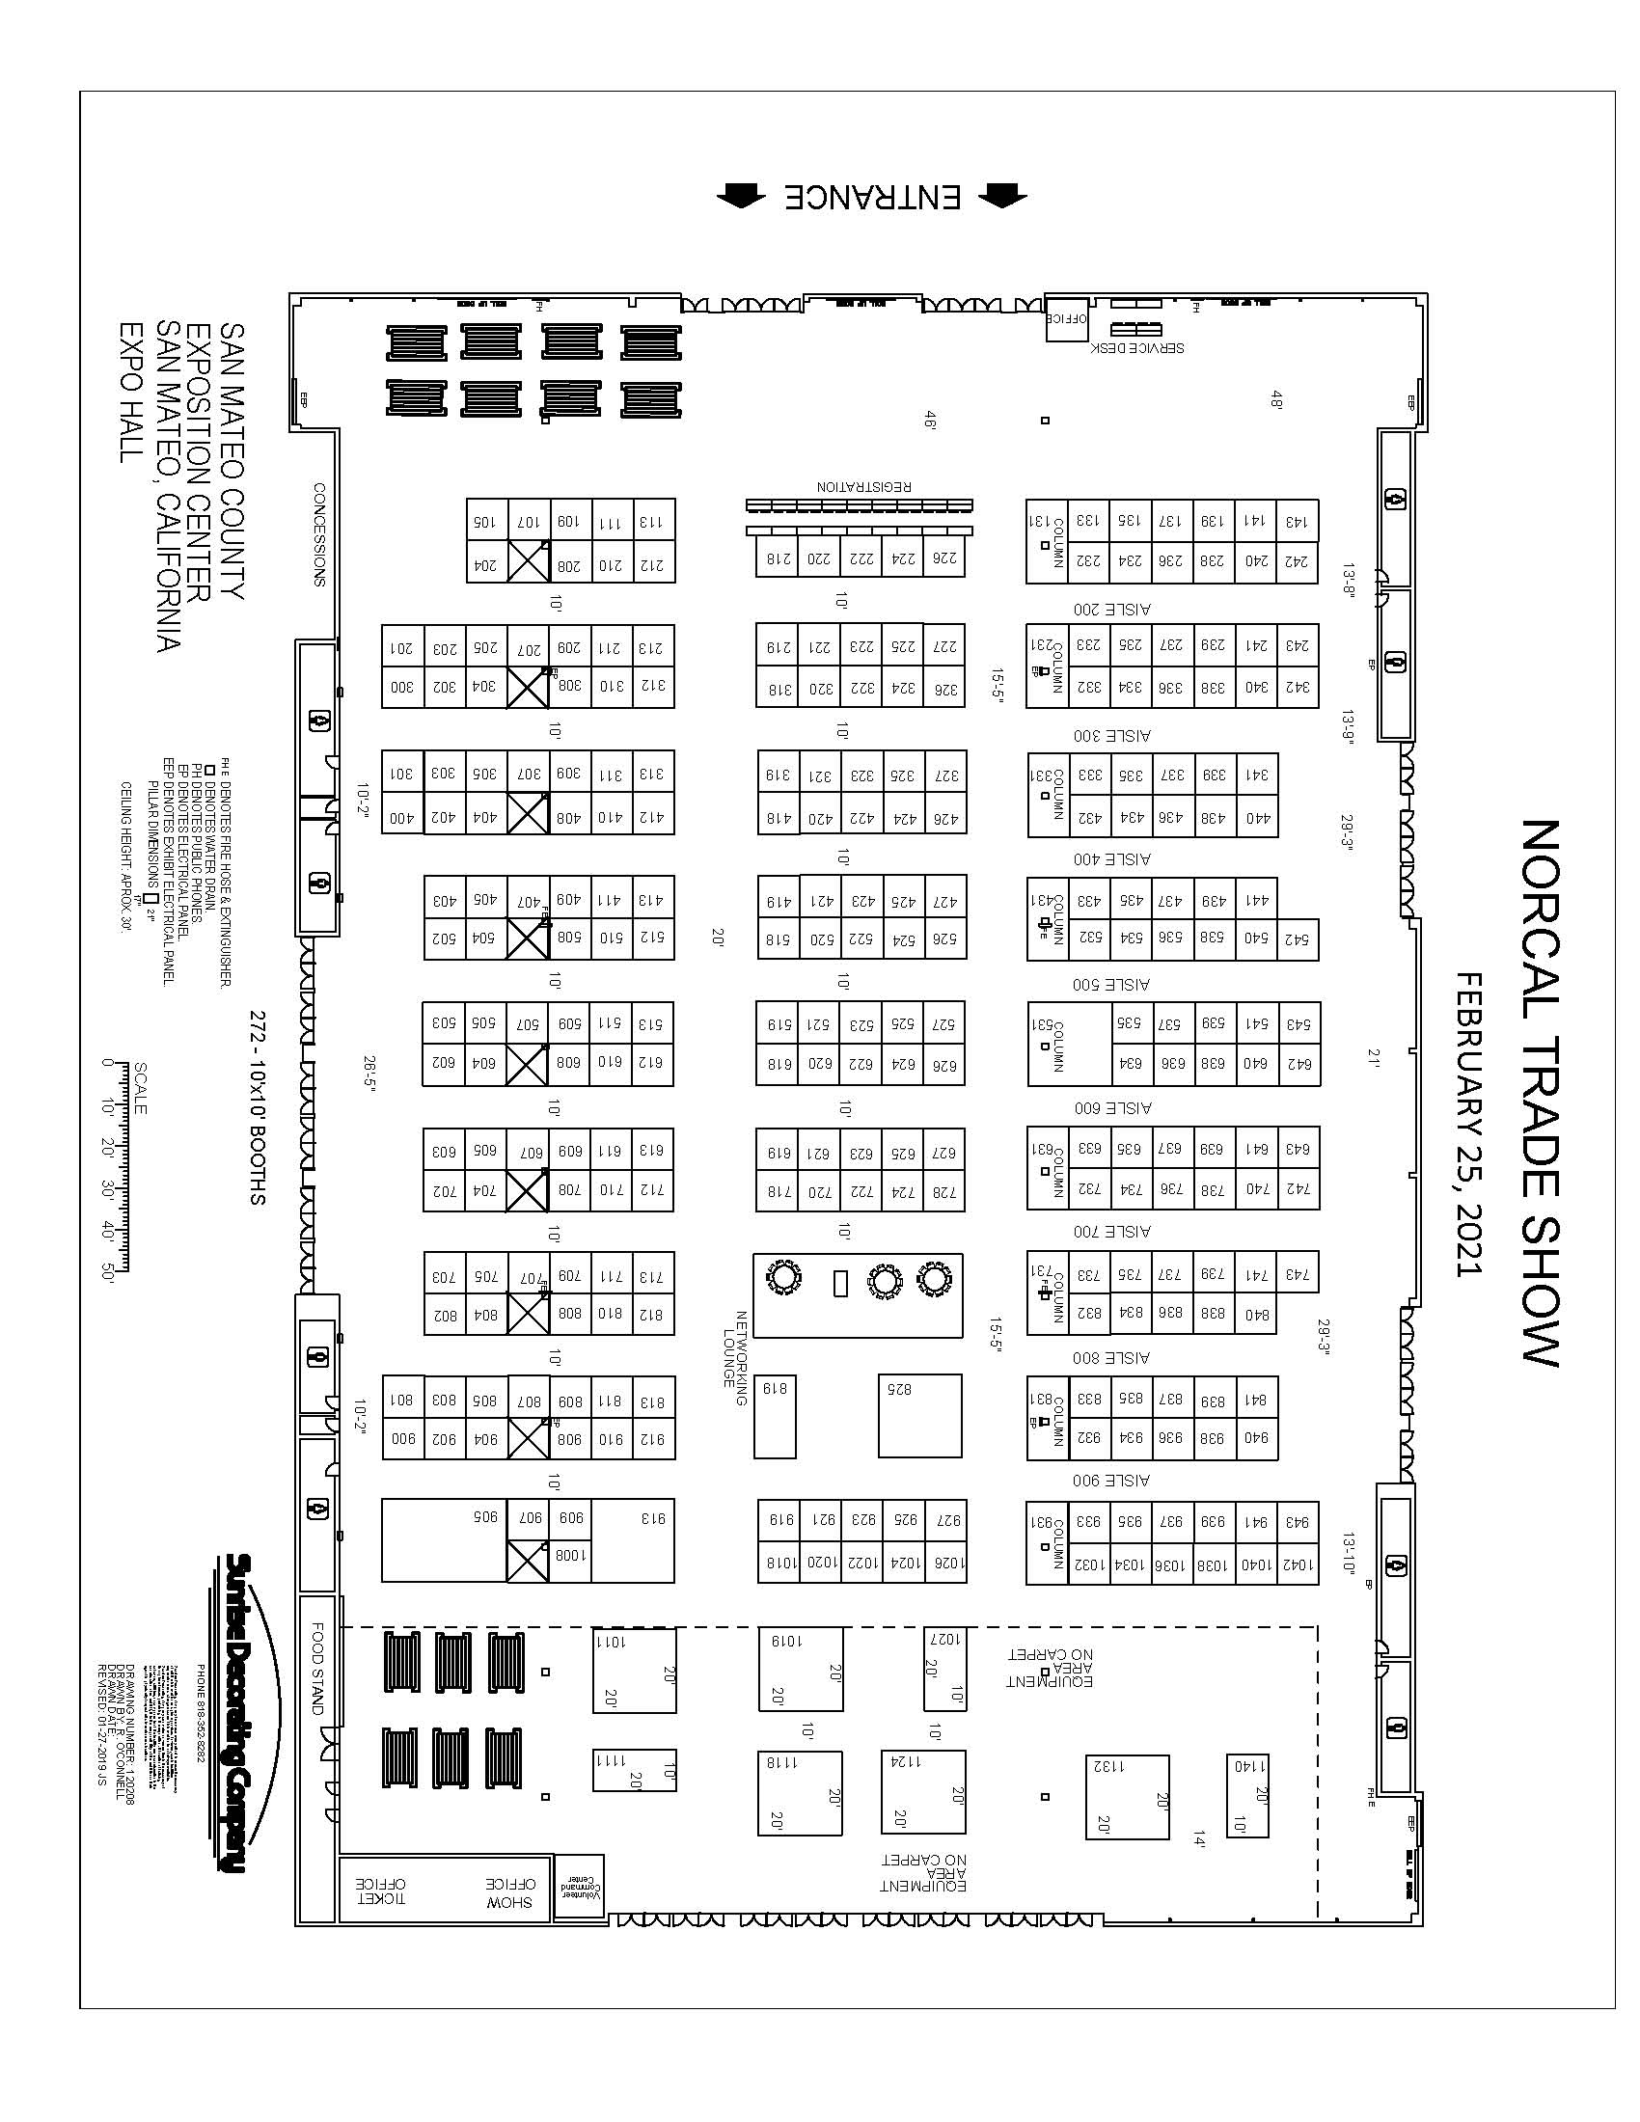

- 23 -

2021 Nor Cal Landscape & Nursery Expo Facility Map

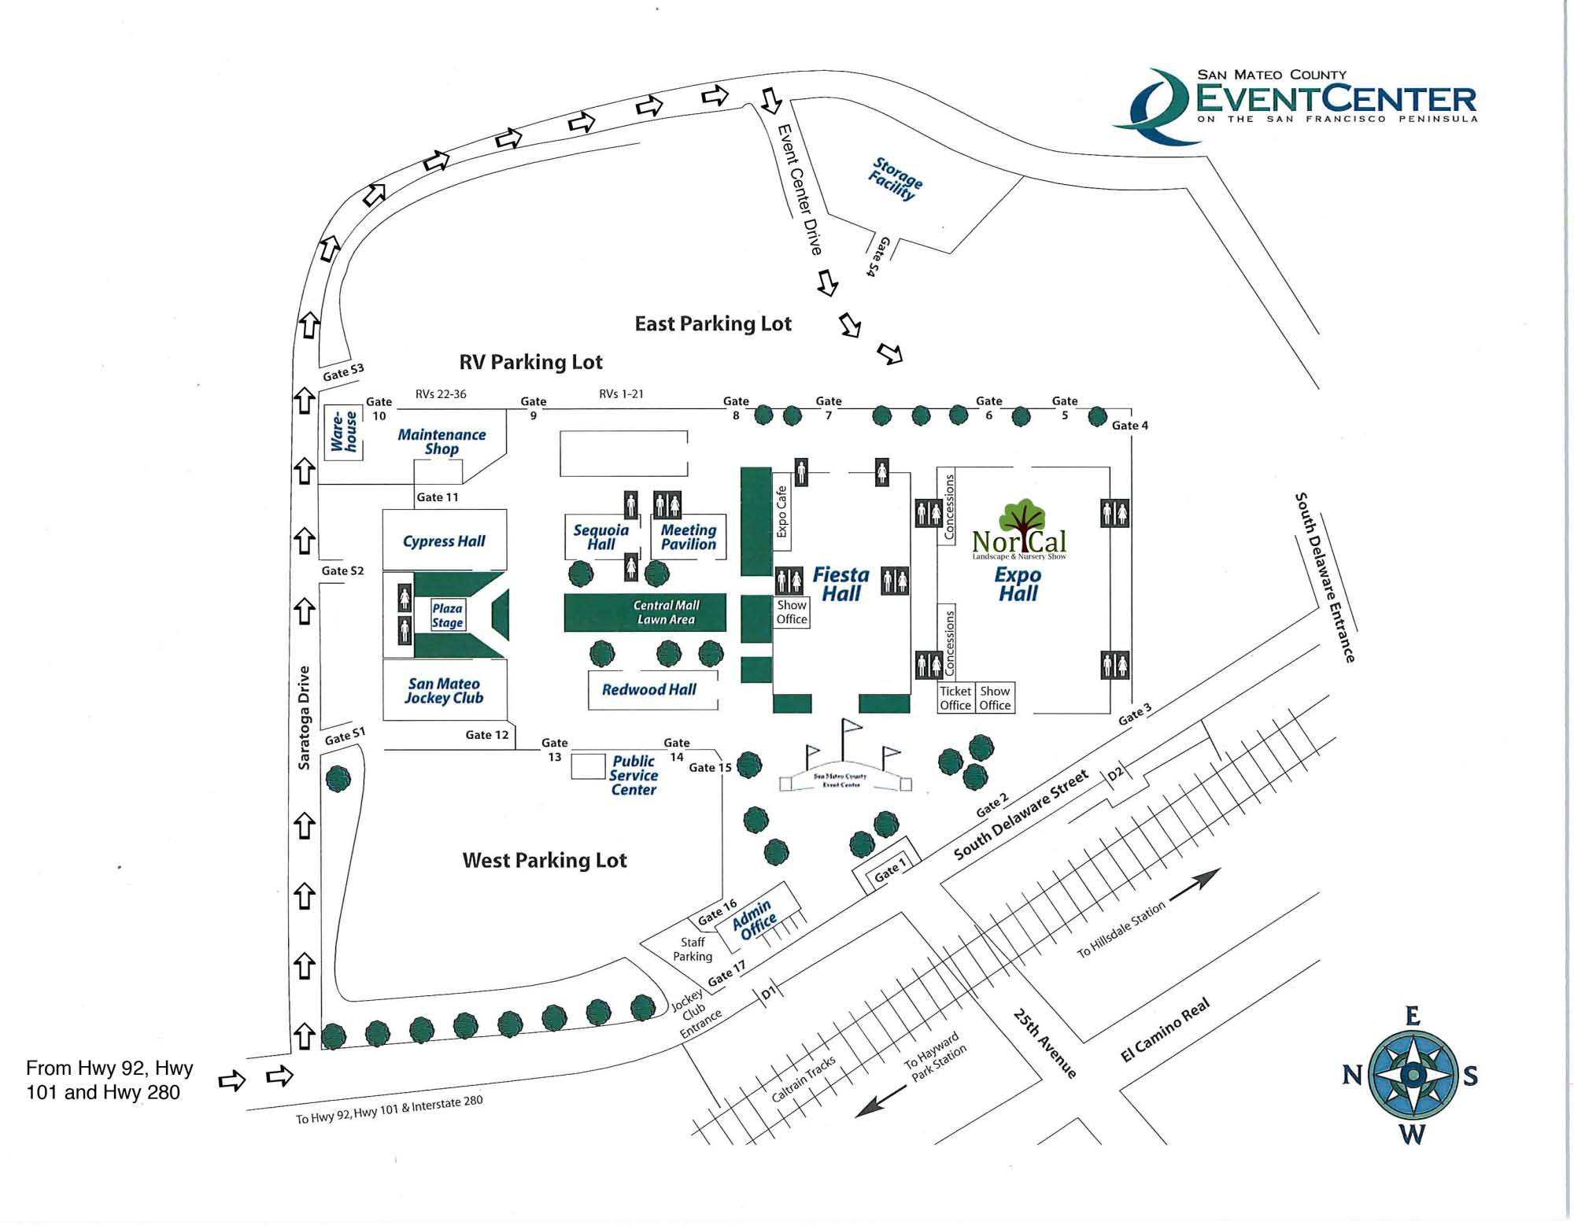
- 24 -

Nor Landscape & Nursery Expo 2020 Name Badge Request Form

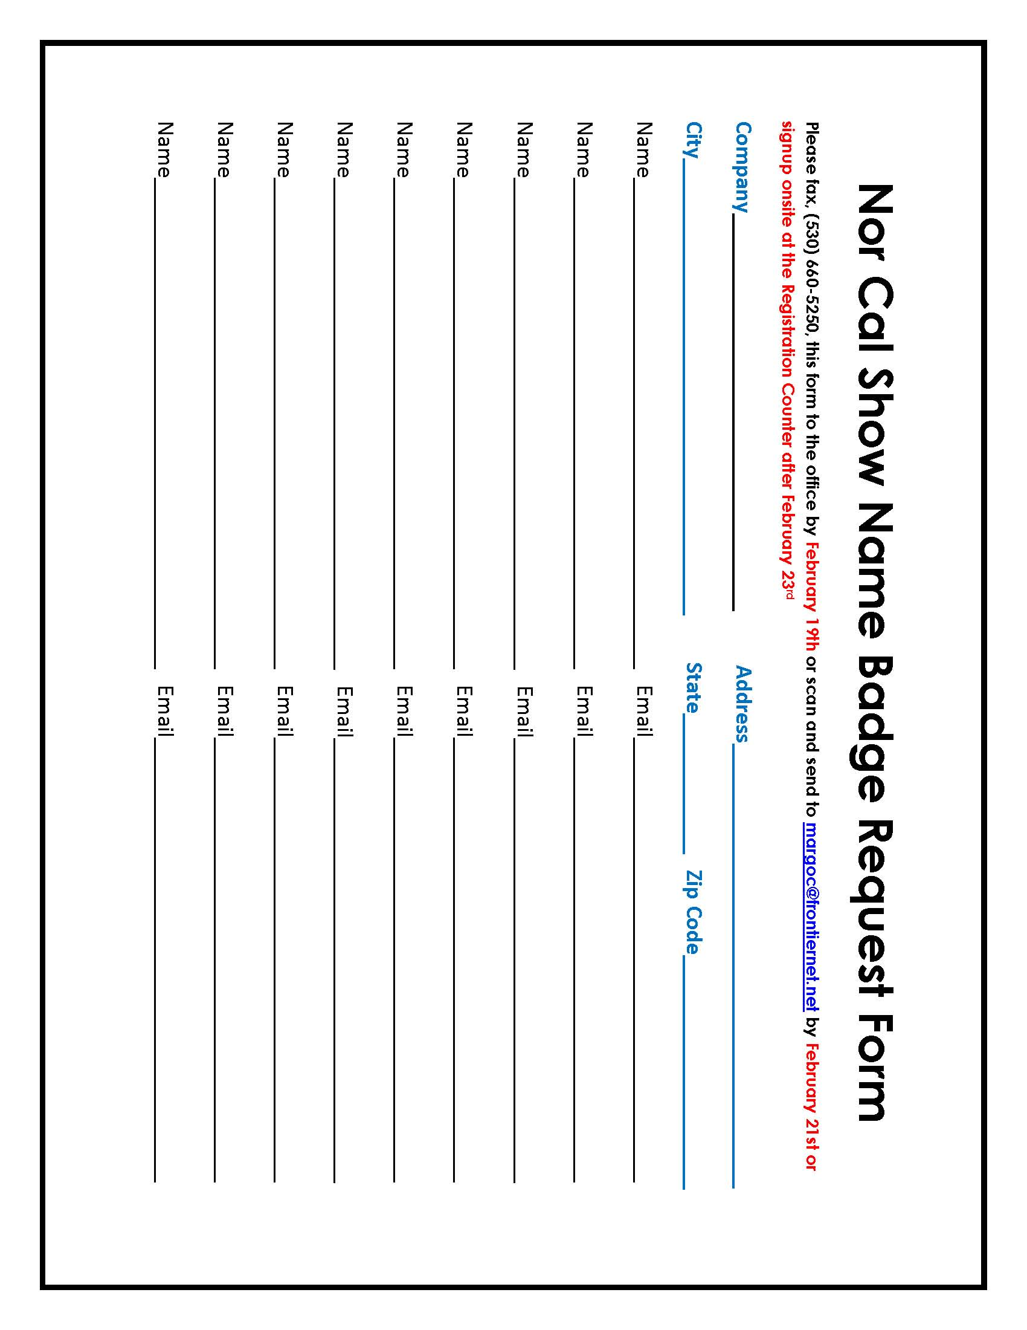

- 25 -

