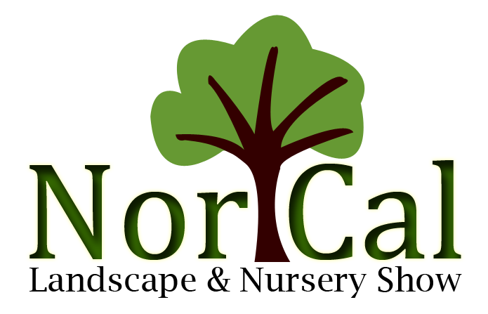
Nor Cal Landscape & Nursery Job Board Listing
You may post a job request on the Nor Cal Job Board by:
- Bring it with you on an 8 ½ x 11 sheet of paper to the show. Include contact information, job description or your experiences.
- Or take the request and payment to the Registration area on set-up or show day. One of the committee members will help you.
- The posting may be either for a job seeker or an employer with an available job.
- The cost is $10. We accept Business checks, Visa, MasterCard.
- Email the form & request to margoc@frontiernet.net
__________________________________________________________
Visa or MasterCard
Number ____________________________________
Expiration ____/____ CVV _________________
Email to margoc@frontiernet.net or Fax to 530-458-3192

